Dragonflies and Damselflies of the Calf
The recording of the Odanata occurring on the Calf has been undertaken annually since 1978 and reported in the Calf of Man Bird Observatory reports. Since 2005 digital records have been maintained and this has led to a more detailed keeping of the records and the numbers of each species.
A total of just 11 species have been confirmed as occurring on the Calf, with Blue-tailed Damselfly and Common Darter being the most regular and numerous of those species seen. Most records come from the Millpond / Withy area, although during autumn, dragonflies, particularly Migrant Hawker, are frequently seen hunting around the Observatory gardens. There are in addition, several small ephemeral ponds located at various places around the islet, which are likely to host Odanata; these are infrequently visited by wardens or anyone specifically looking for these insects and it is likely that most species are under-recorded.
Undoubtedly, a more systematic approach to looking for dragonflies and damselflies would increase our understanding of the status of several species, as well as likely adding species not yet seen on the Calf. Several species occur commonly on the main Island, but which are yet to be recorded on the Calf of Man.
Common Blue Damselfly Enallagma cyathigerum
The true status of this species is not known, and it is possible that previous records may have been mis-identified or that the species is often over-looked amongst the hundreds of Blue-tailed Damselflies that occur.
Two records were reported in 1999, with three at the Millpond on 6th August and a further single on 9th September. Two more were recorded in the Observatory daily log on 17th June 2014, although the record was not included in the annual report and finally one was recorded on 9th June 2018.
Blue-tailed Damselfly Ischnura elegans
Easily the most abundant species of Odanata occurring on the Calf, with regular counts of up to 100 individuals. Several higher counts were recorded in 2005 with peak numbers of 204 in May, 247 in June and 235 in July. A further high count of 200+ was made on 5th June 2018. Most records come from the Millpond, however in some years the small brackish pool at South Harbour has produced a few records.
Apr |  | May |  | June | July | Aug | Sep |  | Oct

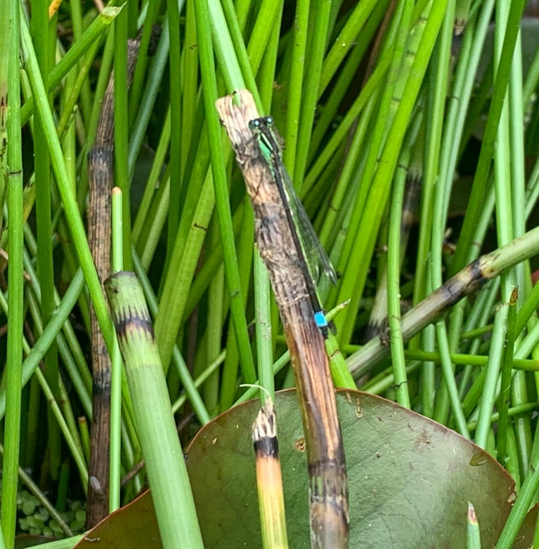

Brown Hawker Aeshna grandis
Five records occurred during 2003 – 2005, with two singles recorded in each of August and September and a single in October.
Common Hawker Aeshna juncea
Up to five records were made almost annually between 1995 – 2004, with additional records in 2007 and 2016. The latter involved a mating pair.
Migrant Hawker Aeshna mixta
First recorded in 2003, records have become almost annual with double figure counts in eight years, including total counts of individuals being 42 in 2006 and 33 in 2019. The species has undoubtedly been recorded more frequently since 2016, with breeding confirmed in 2019.
July | Aug |  |  |  | Sep |  |  |  | Oct |  |  |  | Nov

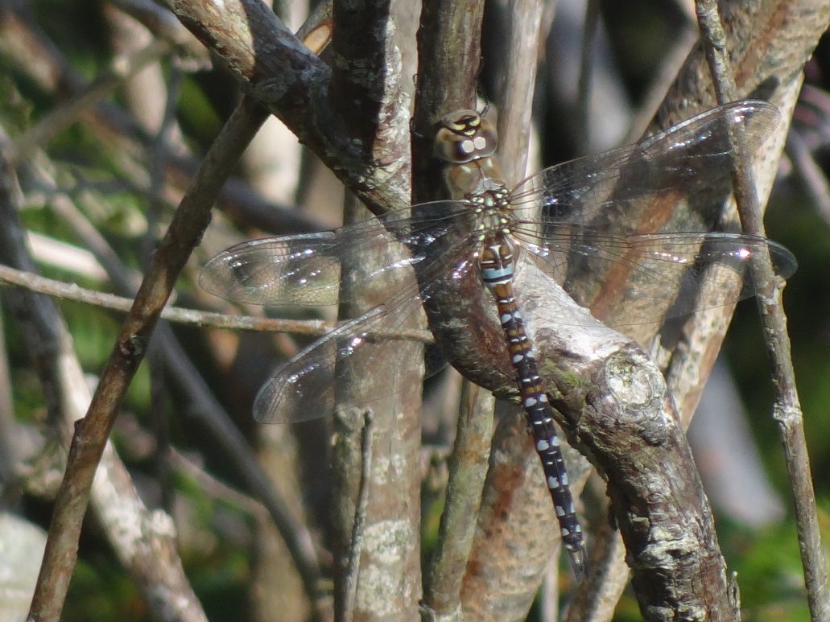

Emperor Amax imperator
First recorded in 2003, further singles were recorded on three dates in 2004, as well as singles in 2005 & 2009. There was then a gap in records until four in 2016, ten in 2019 when an ovipositing female was observed on 23rd August, and six in 2020.
May | June |  |  |  | July |  |  |  | Aug |  |  |  | Sep |  |  |  | Oct |  |  |  | Nov

Vagrant Emperor Hemianax ephippiger
A single seen and later trapped at the Millpond on 12th July 1995. The specimen was sent to Liverpool Museum where its identity was confirmed.
Four-spotted Chaser Libellula quadriaculata
Five individuals have been recorded with singles on 4th June 1978, 12th July 1995, 8th July 1997, and 27th & 28th July 2001. The latter two records could potentially be of the same individual, although sightings were at Jane’s House and the Mill Giau respectively, which are quite some distance apart.

Black Darter Sympetrum danae
The only records were of two on 19th September and a single on 22nd September 1978.
Ruddy Darter Sympetrum sangwineum
Singles recorded frequently at Withy during 1997, between 26th August - 22nd September.
Common Darter Sympetrum striolatum
Commonly recorded from the Millpond, with counts of up to 10 being frequent during July to September each year. Counts in excess of 20 have been made on a number of occasions with a maximum of 29 reported on 21st July 1997.
May |  |  | June |  |  |  | July |  |  |  | Aug |  |  |  | Sep |  |  |  | Oct |  |  |  | Nov

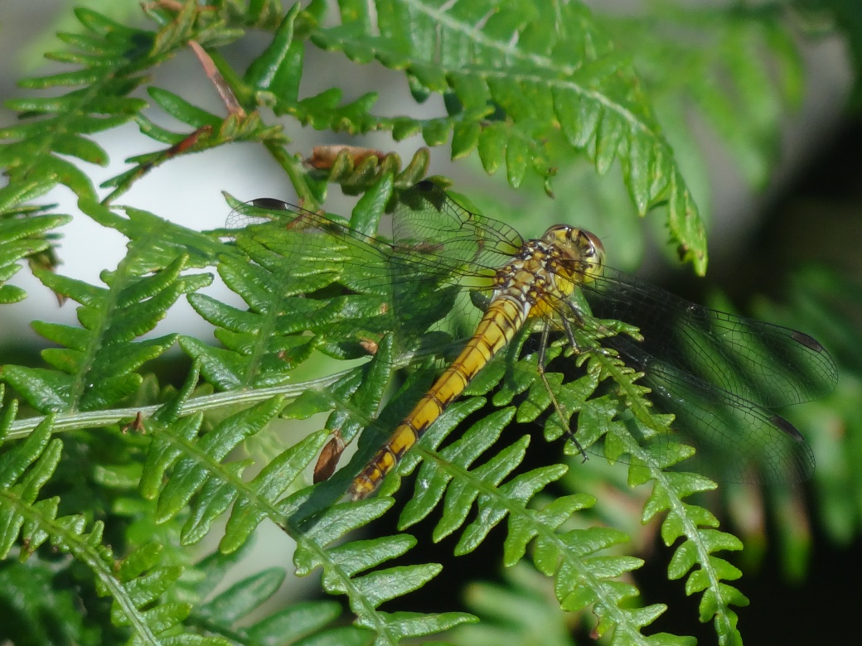

In addition to the above, there have been five other species that have been recorded as occurring on the Calf but for which the records have not been sufficiently substantiated and are therefore not included in the above list of confirmed species:
- Golden-ringed Dragonfly Cordulegaster boltonii – a single reported in 1988, however no date of observation or detail of the record was provided.
- Black-tailed Skimmer Orthetrum cancellatum – a single recorded on 17th September 2009 has now been withdrawn by the observers.
- Keeled Skimmer Orthetrum coerulescens - a male was seen in Mill Giau on 5th September 2001.
- Azure Damselfly Coenagrion puella – a single was reported from the Millpond on 24th June 2018.
- Broad-bodied Chaser Libellula depressa - a single was reported from the Millpond on 24th June 2018.

Acknowledgement:
I am grateful to Manx National Heritage for allowing records from the Calf of Man Bird Observatory reports to be accessed and used for the purpose of writing this review. I would also like to acknowledge the help of several other people in undertaking this review, particularly Christa Worth for her assistance in collating and checking the historical records and Peter Hadfield for providing the flight period charts and constructive comment on this paper.

Photo Credits:
Blue-tailed Damselfy - Rob Fisher
Migrant Hawker - Daniel Woollard
Common Darter - Daniel Woollard

